Transport4You

Requirements Definition

Version 3.3

Doc. No.:

Revision History

Date | Version | Description | Author
2010-10-1 | 1.0 | First draft. | Toni Pivčevič, Dajan Zvekić
2010-10-8 | 1.1 | Added a requirement, minor change in 3.1 UML Diagram | Gaurav Kushwaha
2010-10-17 | 2.0 | Added requirements and use cases. @See change log. | Toni Pivčevič, Dajan Zvekić
2010-11-20 | 3.0 | Some requirements explained, Introduction | Dajan Zvekić
2010-12-05 | 3.1 | Requirements changes. @See change log.  Requirements explanations. | Dajan Zvekić, Toni Pivčević
2011-01-31 | 3.2 | Requirements changes. @See change log. | Dajan Zvekić
2011-12-26 | 3.3 | User -> Passenger | Dajan Zvekić

Table of Contents
1. Introduction 4
1.1 Purpose of this document 4
1.2 Intended Audience 4
1.3 Scope 4
1.4 System boundaries 4
1.4.1 External interfaces 4
1.5 Definitions and acronyms 5
1.5.1 Definitions 5
1.5.2 Acronyms and abbreviations 5
1.6 References 5
2. Requirements Description 5
2.1 Introduction 6
3. Use Case Models 6
3.1 Actors 6
3.2 Web model use cases 6
3.2.1 Use case “Passenger Registers” 6
3.2.2 Use case “Passenger prepays ticket on web” 7
3.2.3 Use case “Passenger subscribes to route” 7
3.2.4 Use case “Passenger prepays tickets in person” 8
3.2.5 Use case “Admin inserts transport line interruption/modification information” 8
3.3 Transport Main Application 8
3.3.1 Use case “Transport line interruption/modification notification” 8
3.3.2 Use case “Transport main application identifies passenger’s standard routes” 9
3.3.3 Use case “Transport route optimization notification” 9
3.4 Transport Unit Application model use cases 9
3.4.1 Use case “Passenger performs multiple route section journey” 10
3.4.2 Use case “Driver starts application” 11
4. Requirements Definition 11
4.1 Requirement Group Definitions 11
4.2 Requirement Sources 11
4.3 Requirements definitions 11
4.3.1 Functional Requirement definitions 11
4.3.2 Non-functional Requirement definition 13
4.3.3 Change Log 14
5. Future Development 14
5.1 General Overview 14

Introduction
Public transport is big part of general organization for big cities. This public transport can be very complicated, as cities can have public bus network, public tram network, subway and etc.
Purpose of this project is to help both in organization of public transport and also to people that are using it. In organization part project will allow easy input of problems and line changes in network and passengers who are travelling will be informed automatically by system about changes and problems in routes, also it will help to easier control passenger payments.
Passengers will have benefit of automatic notifications for their standard routes, also payment will be automatic, so what passenger needs to do is to sign up on web application and choose payment mode. If this mode allows automatic payment, passenger won’t need to manually buy tickets and activate them. For, every activated ticket passenger will get SMS notification. In real life passenger will have to turn on their Bluetooth or Wi-Fi device on their mobile phones, so system can detect passenger.

Purpose of this document

This document will provide a list of the project requirements. Identification and analysis of requirements is key to the projects overall success, especially during the next design phase. The expected change of requirements will cause this document to have multiple versions. Requirements will contain both functional and non-functional sections, gathered from official project customers, external stakeholders and internal team brainstorming sessions. Detailed study of this document will provide the reader with a general overview of the overall system.

Intended Audience
Intended audience includes:
- Team members
- Project leader(s)
- Supervisor(s)
- Customer(s)

Scope
The project scope defines the limitations and range of the proposed solution. For successful usage, the system requires that registered passengers posses a mobile phone with WIFI or Bluetooth technology. Additional mobile software is not required. Every notification sent to the passenger will be in the form of a SMS message. The system will save personal route information for each passenger, and notify when most regularly used routes become interrupted or modified. The system will not provide a route planning service.
A web application, supporting all modern web browsers, will be available for passenger registration, ticket pre-payment, route subscription, overview and administration.

System boundaries

External interfaces

Transport Unit Application external interfaces

Interface name | Description | Direction
GPRS device | TUA has to send/receive GPRS data. | TUA→GPRS device
WIFI device | TUA has to detect MAC addresses of all passengers currently in the TU’s WIFI network range. | TUA→WIFI device
Bluetooth device | TUA has to detect MAC addresses of all passengers currently in the TU’s Bluetooth network range. | TUA→Bluetooth device
Event Handler | TUA must handle events from TU:  - TU arrives at station (i.e. doors open)  - TU leaves station (i.e. doors close) | TU event fire→TUA
GPS device | TUA has to know TU’s GPS coordinates. | TUA →GPS device

Transport Main Application external interfaces
Interface name | Description | Direction
SMS gateway | TMA has to send SMS message notifications to passengers. | TMA → SMS gateway
Credit-card payment service | TMA has to provide payment by credit-card. | TMA → credit card service
GPRS device | TMA has to send/receive GPRS data. | TMA→GPRS device

Transport Web Application external interfaces
Interface name | Description | Direction
Web browser | Web passenger interface | TWA → Passenger

* Direction indicates which component is hidden behind an interface.

Definitions and acronyms

Definitions

Keyword | Definitions
Transport line | One line of transport network.
Route section | Journey on a section of transport line performed by passenger.
Route | Journey performed by passenger. Sorted collection of route sections.
Payment type | The type of a particular payment instance.
Payment mode | Payment strategy application takes when billing passenger.

Acronyms and abbreviations

Acronym or  abbreviation | Definitions
SMS | Short Message Service
Wi-Fi | Wireless Fidelity
Transport4You | Transport For You

References
- Project specification by SCORE
  - http://score-contest.org/2011/projects/DiNittoRossi.Transport4You.pdf
- Project homepage
  - http://www.fer.hr/rasip/dsd/projects/transport4you1

Requirements Description

Introduction
In the following sections all the requirements of the system will be listed in form of use cases, functional and non-functional requirements.

Use Case Models

Actors
Keyword | Definitions
Passenger | Citizen using public transportation.
Admin | System administrator.
Driver | Person employed as driver of transport unit.
TMA | Transport main application.

Web model use cases
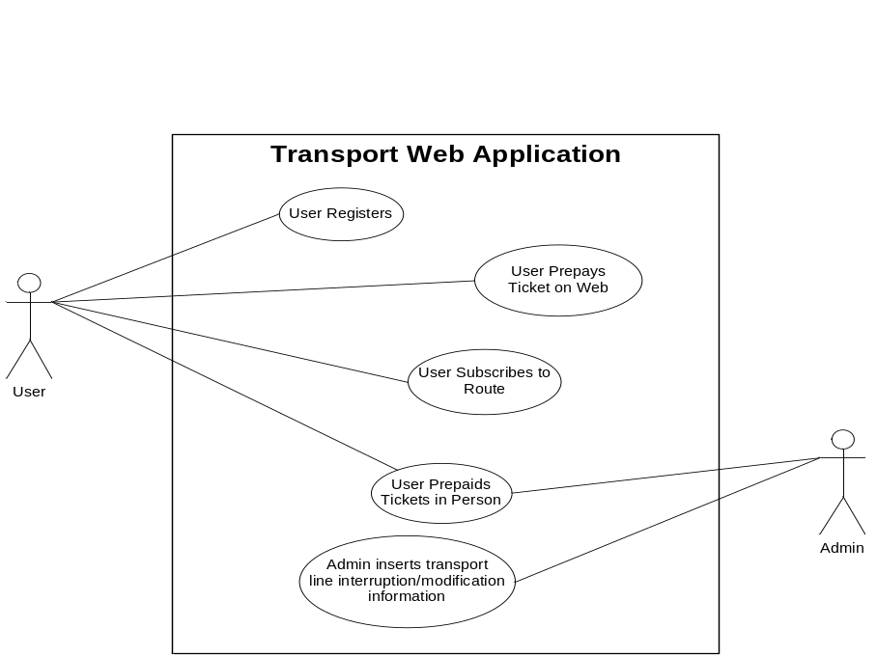

Use case “Passenger Registers”

Initiator:
Passenger.
Goal:
Passenger is successfully registered in Transport4You system.
Requirements:
- Functional:
TWA1, TWA2, TWA3, TWA4.
- Non-functional:
TWA1, TWA2.
Main Scenario:
- Passenger chooses to register.
- Passenger inputs personal information.
- Passenger inputs cell phone information.
- Passenger inputs profile options.
- Passenger chooses ticket payment mode.
- Application validates passenger data.
- Application saves passenger data.
- Application confirms successful registration.

Extensions:
4a. Passenger chooses credit card payment.
- Passenger inputs credit card information.
5.b Validation unsuccessful.
- Application signals invalid data to passenger.
- Passenger re-enters data (step 2).

Use case “Passenger prepays ticket on web”
Initiator:
Passenger.

Goal:
Passenger successfully buys tickets.
Requirements:
- Functional:
TWA5, TWA6.
- Non-functional:
TWA1, TWA2.
Main Scenario:
- Passenger logs into application.
- Passenger chooses to buy tickets.
- Passenger chooses ticket type.
- Passenger chooses number of ticket to buy.
- Passenger confirms purchase.
- Application makes payment through credit card service.

Extensions:
6b. On unsuccessful payment, application signals error to passenger.

Use case “Passenger subscribes to route”
Initiator:
Passenger.

Goal:
Passenger is subscribed to route and will receive notifications about route interruptions/modifications.
Requirements:
- Functional:
TWA8.
- Non-functional:
TWA1, TWA2.
Main Scenario:
- Passenger logs into application.
- Passenger chooses route subscription.
- Passenger selects route.
- Passenger confirms route subscription.

Use case “Passenger prepays tickets in person”
Initiator:
Passenger.

Goal:
Passenger successfully buys tickets.
Requirements:
- Functional:
TWA7.
- Non-functional:
TWA1, TWA2.
Main Scenario:
- Passenger arrives at cashier.
- Passenger chooses ticket type and amount.
- Cashier makes payment.
- Cashier updates passenger’s prepaid ticket status on web.

Use case “Admin inserts transport line interruption/modification information”
Initiator:
Admin.

Goal:
Information about transport line interruption/modification is updated.
Requirements:
- Functional:
TWA7.
- Non-functional:
TWA1, TWA2.
Main Scenario:
- Admin receives information about current/planned transport line interruption/modification.
- Admin updates transport line information according to current status.
- System notifies passengers that are most probably affected.

Transport Main Application
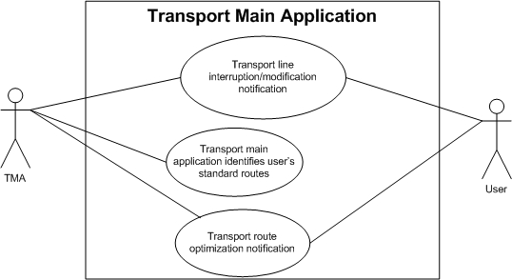

Use case “Transport line interruption/modification notification”
Initiator:
Admin.

Goal:
Information about transport line interruption/modification is updated and passengers that are most likely affected are notified.
Requirements:
- Functional:
TMA6, TWA8.
- Non-functional:
TWA1, TWA2.
Main Scenario:
- Admin inserts transport line interruption/modification information.
- Application identifies passengers that are affected by this interruption/modification.
- Application notifies identified passengers or passengers that are subscribed to routs that are affected.
- Additional application informs passengers about possible alternative lines.

Use case “Transport main application identifies passenger’s standard routes”
Initiator:
TMA.

Goal:
Transport main application identifies passenger’s standard routes.
Requirements:
- Functional:
TMA4, TMA5.
- Non-functional:
Main Scenario:
- Transport main application performs scheduled standard route identification.

Use case “Transport route optimization notification”

Initiator:
TMA.

Goal:
Transport main application identifies passenger’s standard routes and performs optimization. Passengers are notified about these optimizations.
Requirements:
- Functional:
TMA4, TMA5, TMA11, TMA12.
- Non-functional:
TMA1.
Main Scenario:
- Transport main application identifies passenger’s standard routes.
- Transport main application performs scheduled optimization.
- Application Transport main application performs scheduled notification.

Transport Unit Application model use cases

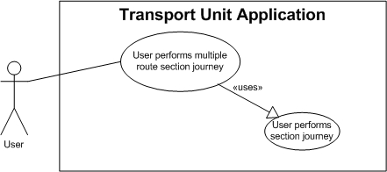

Use case “Passenger performs multiple route section journey”
Initiator:
Passenger.
Goal:
Passenger performs journey. Passenger is correctly billed. Route information is saved.

Requirements:
- Functional:
TMA1, TMA2, TMA3, TMA4, TUA1, TUA2.
- Non-functional:
TMA1, TUA1, TUA2, TUA3.
Main Scenario:
- Passenger enters transportation unit.
- Transportation unit application smartly detects passenger presence.
- If no valid ticket is associated with passenger, passenger is billed and notified.
- Transportation unit application smartly detects passenger absence.
- Passenger route section data is saved.
Passenger repeats steps 1-5 until journey is completed.
Extensions:
3a. If passenger has SMS payment.
1. Notification is sent to passenger to buy ticket.
2. Passenger buys ticket through SMS service.
3. Passenger is notified about successful ticket purchase.

3b. If passenger has on demand payment and credit card service fails.
1. Notification is sent to passenger to buy ticket through SMS service.
2. Passenger buys ticket through SMS service.
3. Passenger is notified about successful ticket purchase.

3c. If passenger has prepaid payment and is out of prepaid tickets.
1. Notification is sent to passenger to buy ticket through SMS service.
2. Passenger buys ticket through SMS service.
3. Passenger is notified about successful ticket purchase.

*a. If passenger fails to purchase ticket.
1. Ticket is added to ticket debt.
*b. System detects ticket expiration.
1. If passenger is currently inside Transport Unit, new ticket is purchased.

Use case “Driver starts application”
Initiator:
Driver.
Goal:
Application is successfully initialized.
Requirements:
- Functional:
TUA5, TMA10.
- Non-functional:
TUA4.
Main Scenario:
- Driver enters transportation unit.
- Driver starts application.
- Driver selects line transport unit is assigned to.
Extensions:
*a. On changes in transport line network.
1. Transport main application sends new data to transport unit application.
2. Transport unit application refreshes line list.
3. Driver can choose new line if needed.

Requirements Definition

Requirement Group Definitions

Identification | Requirement Group | Rem.
TMA | Transport Main Application
TUA | Transport Unit Application
TWA | Transport Web Application

Requirement Sources

Source | Description | Rem.
SCTM | Official SCORE customer.
SDOC | Official SCORE project document.
DT | Development team.
SYS | Required by system design.

Requirements definitions

Functional Requirement definitions

Identity | Status | Priority | Description | Source
 |  |  | Transport Main Application
F-TMA1 | I | 1 | Application enforces billing. | SDOC
F-TMA2 | I | 1 | Application notifies passengers about payment:  - On payment success.  - Reminder to pay ticket.  - On payment failure.  - On ticket expiration. | SDOC, DT
F-TMA3 | I | 1 | Application checks when ticket is expired and if passenger is still in vehicle application buys new ticket. | DT
F-TMA4 | I | 1 | Application records routes of every passenger. | SDOC
F-TMA5 | I | 1 | Application performs scheduled standard route identification. (Finding standard passengers routes based on existing data about passengers) | SDOC
F-TMA6 | I | 1 | Application notifies passengers about routes and suggests alternative:  - Interruption in standard route.  - Modification to standard route.  - Optimization to standard route. | SDOC, DT
F-TMA7 | I | 2 | If system crashes tickets are archived. (Passenger will not lose its active tickets because of system crash) | DT
F-TMA8 | I | 2 | If system crashes passengers are notified. | DT
F-TMA9 | I | 2 | If system crashes control is notified. | DT
F-TMA10 | A | 1 | System provides transport line data pushing when changes occur to transport unit application. | DT
F-TMA11 | A | 2 | Application performs scheduled route optimization. | DT
F-TMA12 | A | 2 | Application performs scheduled route optimization notification. | DT
F-TMA13 | A | 2 | Application has structured schema for network input. | DT
 |  |  | Transport Unit Application
F-TUA1 | I | 1 | Application smartly detects passengers inside vehicle. | SDOC
F-TUA2 | I | 2 | Application sends passengers current route section data to TMA:  - GPS location where passenger enters vehicle.  - GPS location where passenger exits vehicle.  - Vehicles transport line.  - Time when passenger enters vehicle.  - Time when passenger exits vehicle. | SYS
F-TUA3 | I | 2 | In case of application crash restart passenger detection. | SYS
TUA4 | I | 2 | In case of application crash notify passengers inside transportation unit. | DT
F-TUA5 | A | 1 | Transport unit driver must select transport unit line at application start or when applies. | DT, SYS
 |  |  | Web Application
F-TWA1 | I | 1 | Passenger registers profile. | SDOC
F-TWA2 | I | 1 | Passenger needs to input personal data:  - Name  - Address  - Password | SDOC
F-TWA3 | I | 1 | Passenger needs to input cell phone data:  - Phone number  - Bluetooth address  - Wi-Fi MAC address | SDOC
F-TWA4 | I | 1 | Passenger can choose billing mode:  - On demand payment  - SMS payment  - Prepaid  (Passenger billing option. How application handles passenger billing.) | SDOC,DT
F-TWA5 | A | 1 | Passenger can choose payment type:  - Credit Card payment  - SMS payment  - Cash payment  (Type of payment transaction. How passenger buys tickets.) | DT
F-TWA6 | I | 2 | Passenger can choose between various ticket types:  - T_VAL ticket (ticket valid for T_VAL period)  - Daily ticket  - Weekly ticket  - Monthly ticket | SDOC,DT
F-TWA7 | I | 2 | Web application has administrative section:  - Passenger choose to pay in cash and admin updates passengers ticket/credit count  - Admin can insert route modification/interruption | DT
F-TWA8 | I | 2 | Passenger can define route and check its availability. | DT
F-TWA9 | A | 2 | Administrator can add news which will be shown on home page. | DT
F-TWA10 | A | 2 | Web application should support internationalization. | DT
F-TWA11 | A | 2 | Web application should offer “remember me” option for login. | DT
F-TWA12 | A | 2 | Web application should offer “password forgotten” option for login. | DT

Non-functional Requirement definition

Identity | Status | Priority | Description | Source
 |  |  | Transport Main Application
NF-TMA1 | I | 1 | Application sends notification by SMS. | SDOC,DT
NF-TMA2 | A | 2 | Network schema is XML based. | DT
 |  |  | Transport Unit Application
NF-TUA1 | I | 1 | Application detects passengers inside but through unique wifi/bluetooth MAC address. | SDOC
NF-TUA2 | I | 2 | Connection between TMA and TUA is GPRS-based. | SDOC
NF-TUA3 | I | 2 | The actions the passenger should proactively perform should be limited, very simple, and suitable to all situations. | SDOC
NF-TUA4 | A | 1 | Transport unit provides simple passenger interface for interaction with driver. | SYS, DT
NF-TUA5 | A | 1 | Communication between TUA and TMA should be secure. | DT
 |  |  | Web Application
NF-TWA1 | I | 1 | Application is available on browsers:  - IE 7+  - Mozilla Firefox 2+  - Google Chrome  - Opera  - Safari | DT
NF-TWA2 | I | 1 | Application should be easy to use. | SDOC
NF-TWA3 | A | 1 | Login and registration should be secure. | DT

Requirement status:
I = initial (this requirement has been identified at the beginning of the project),
D = dropped (this requirement has been deleted from the requirement definitions),
H = on hold (decision to be implemented or dropped will be made later),
A = additional (this requirement was introduced during the project course).

Change Log

Identity | Status | Action | Date | Comments
F-TMA5 | C | Changed requirement | 2010-10-17 | Changed description of requirement.
F-TMA10 | A | Added requirement | 2010-10-17 | Requirement identified by development team.
F-TMA11 | A | Added requirement | 2010-10-17 | Requirement identified by development team.
F-TMA12 | A | Added requirement | 2010-10-17 | Requirement identified by development team.
F-TUA5 | A | Added requirement | 2010-10-17 | System design requirement.
NF-TUA4 | A | Added requirement | 2010-10-17 | System design requirement.
F-TUA4 | D | Dropped requirement | 2010-12-5 | Development team requirement
F-TMA8 | D | Dropped requirement | 2010-12-5 | Development team requirement
F-TWA4 | C | Changed requirement name | 2010-12-5 | System design requirement, development team requirement
F-TMA13 | A | Added requirement | 2010-12-5 | Development team requirement
NF-TMA2 | A | Added requirement | 2010-12-5 | Development team requirement
F-TMA9 | D | Requirement deleted | 2010-12-5 | Development team requirement
F-TWA9 | A | Added requirement | 2010-12-5 | Development team requirement
F-TWA10 | A | Added requirement | 2010-12-5 | Development team requirement
F-TWA11 | A | Added requirement | 2011-01-30 | Development team requirement
F-TWA12 | A | Added requirement | 2011-01-30 | Development team requirement
NF-TWA3 | A | Added requirement | 2011-01-30 | Development team requirement
NF-TUA5 | A | Added requirement | 2011-01-30 | Development team requirement

Requirement status:
C = changed (requirement changed)
D = dropped (this requirement has been deleted from the requirement definitions),
H = on hold (decision to be implemented or dropped will be made later),
A = added (this requirement was introduced during the project course).
R = resurrected (dropped or on hold requirement was reactivated)

Future Development

General Overview
- Mobile application and/or web application for live transport system overview with information about current location, estimated time of arrival at station, traffic…
- Mobile application and/or web application for smart/optimized route planning.
- New detection technologies (RFID)
- Mobile application for ticket payment and notifications.
- Integration with google calendar.
- Route optimization takes into account current traffic situation.

